**KUBERNETES TASK 1**

1. Setup Minikube in your local machine.  
   Create a docker desktop on windows first.

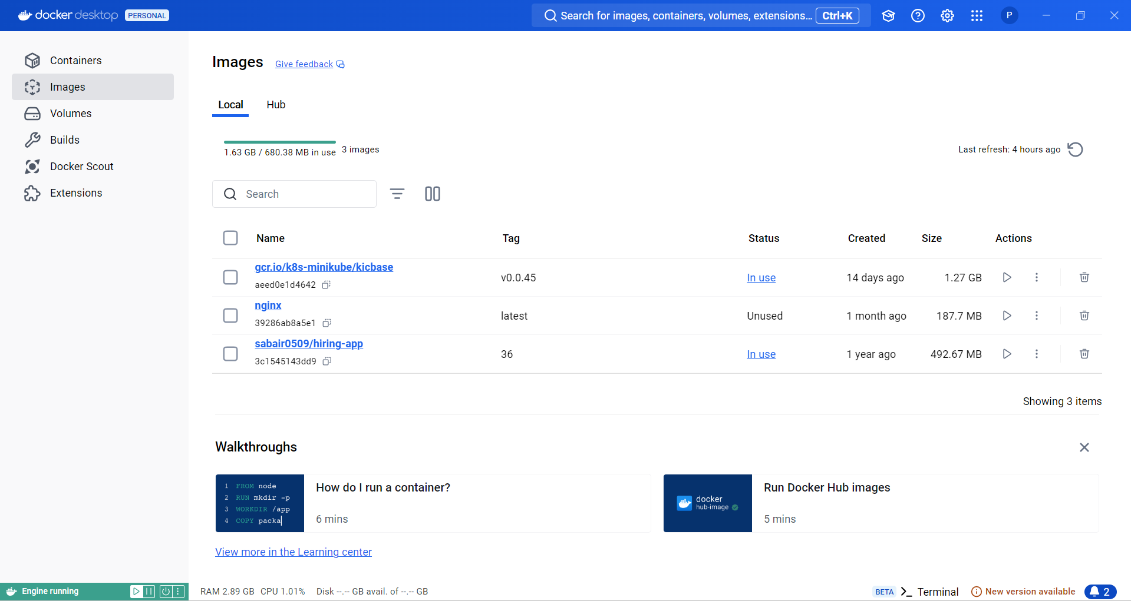

ERRORS: wsl2 version errors and wsl upstream error, environment variables   
are solved here.  
Run desktop don’t login.  
wsl –set-default-version 2

add docker desktop in environmental variables

Go to path and then add minikube

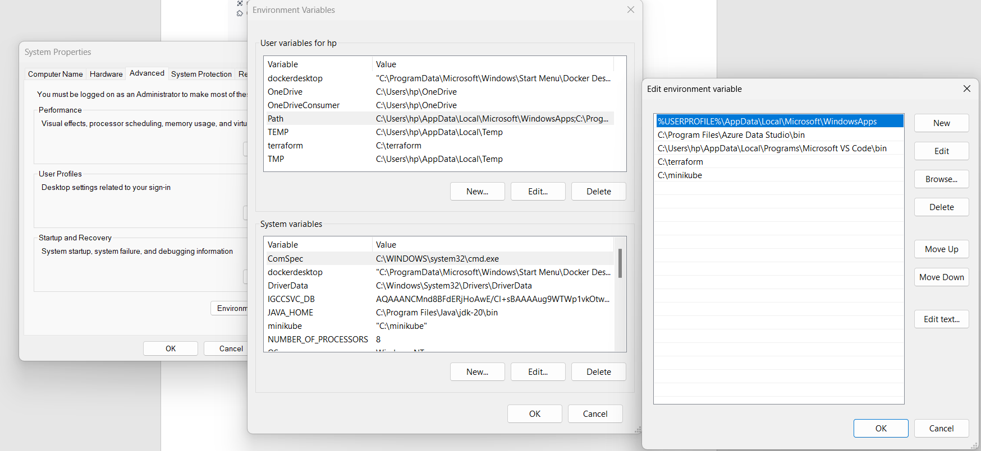

Now Install Oracle box on windows

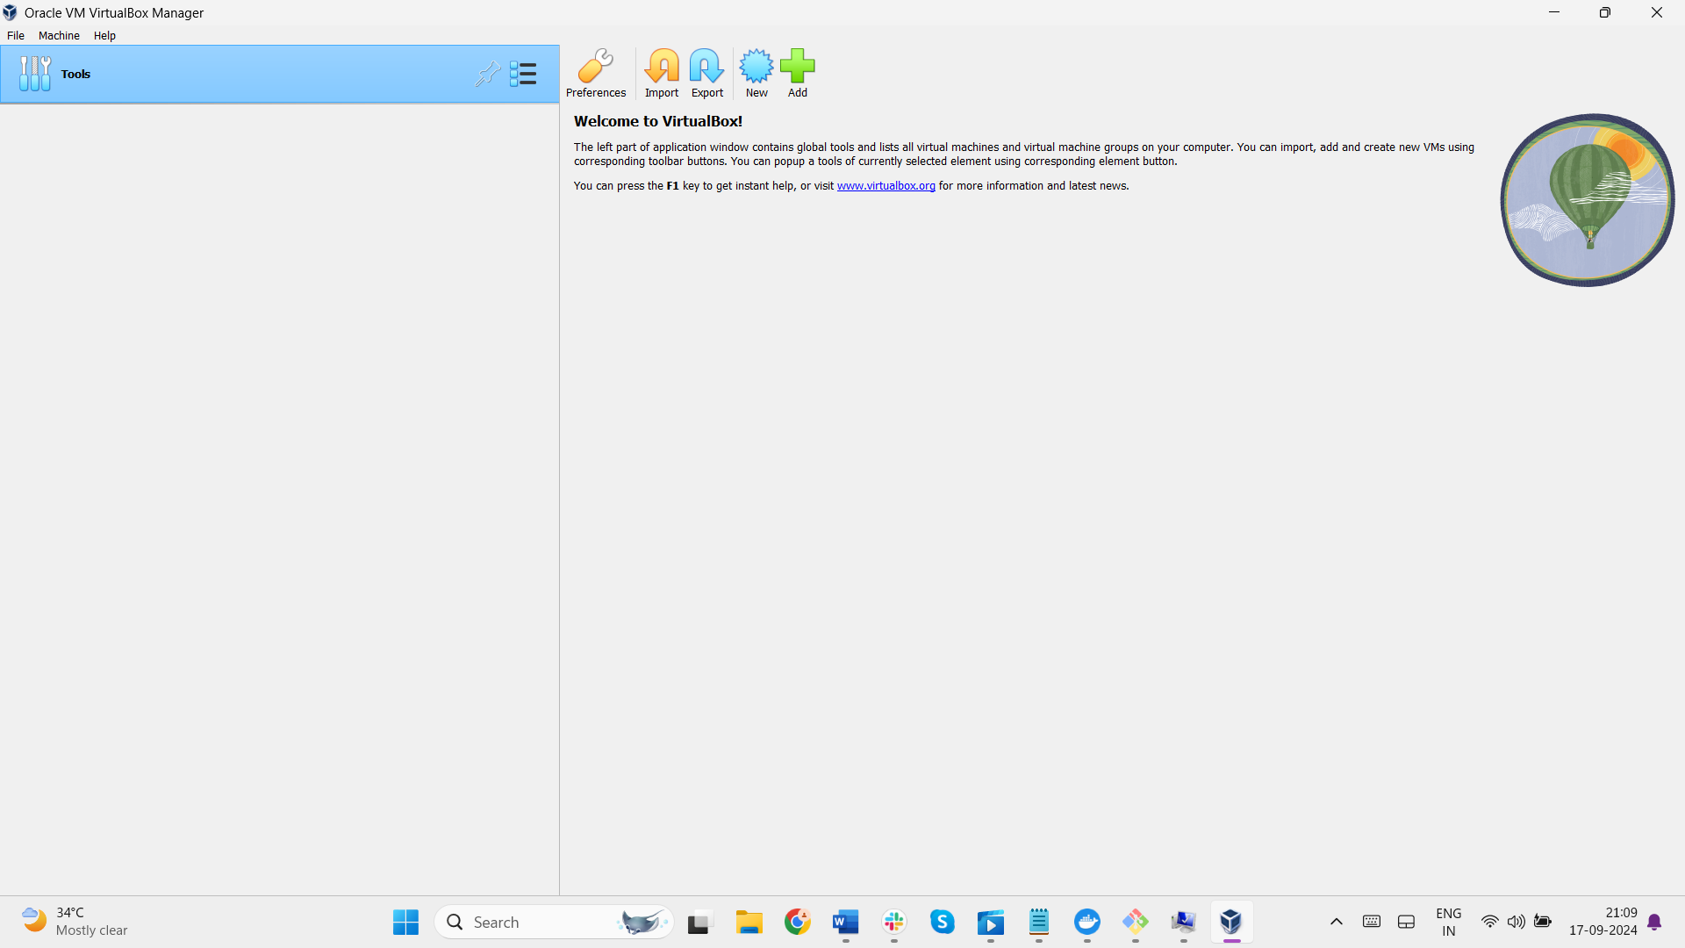

Run systeminfo command to check weather hyper-v enabled or not.

Goto gitbash and type systeminfo

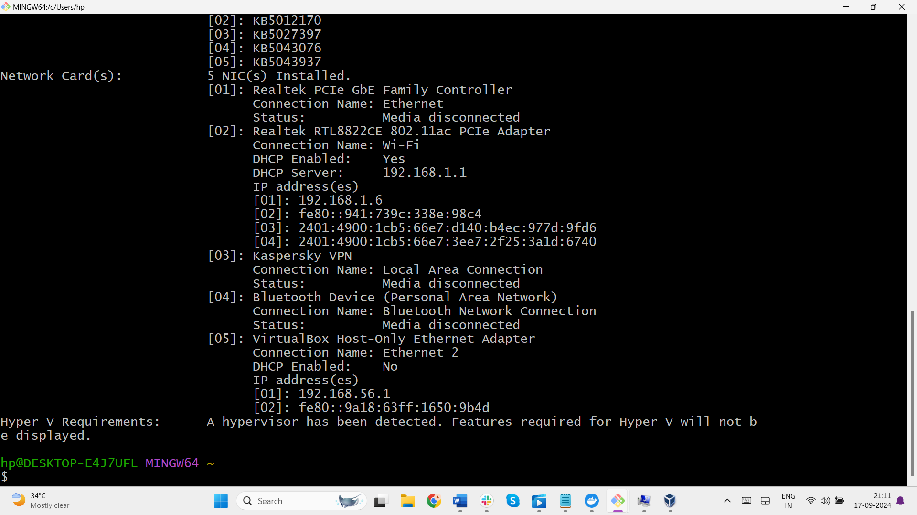

Downloaded the minikube in local machine successfully

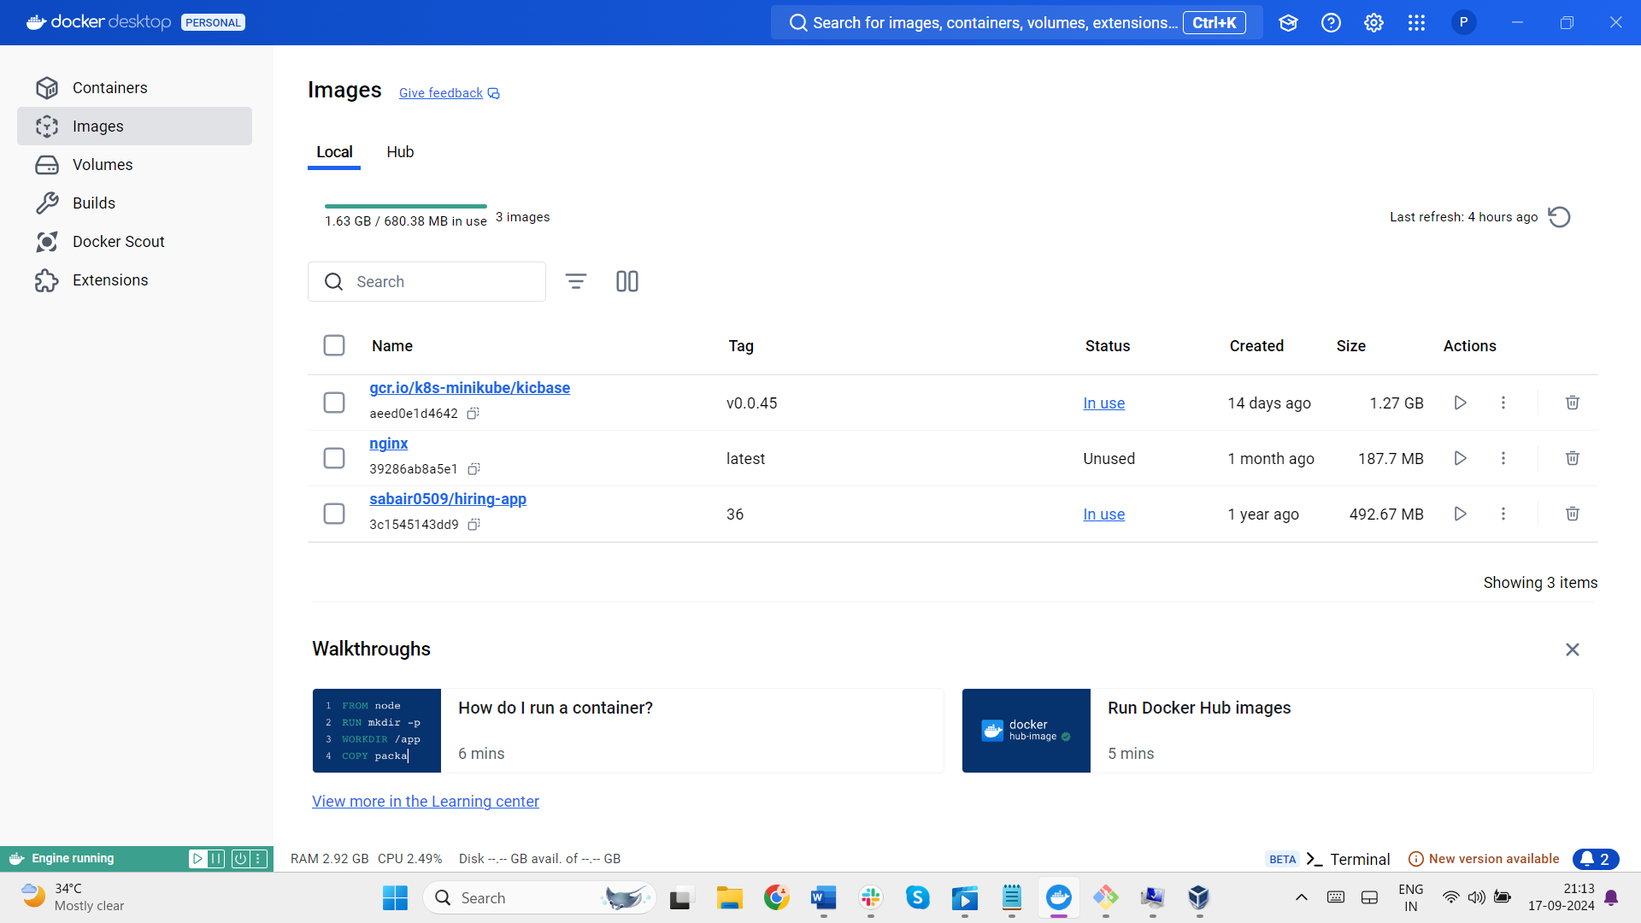

Install Minikube using powershell  
https://minikube.sigs.k8s.io/docs/start/  
add minikube path in the environmental variables



--Then now run the command  
--Minicube start  
--It will download all the required base images.

--Minikube ip  
--To check ip of minikube  
--Minikube ssh  
--Its used to login  
--Successfully created the minikube.

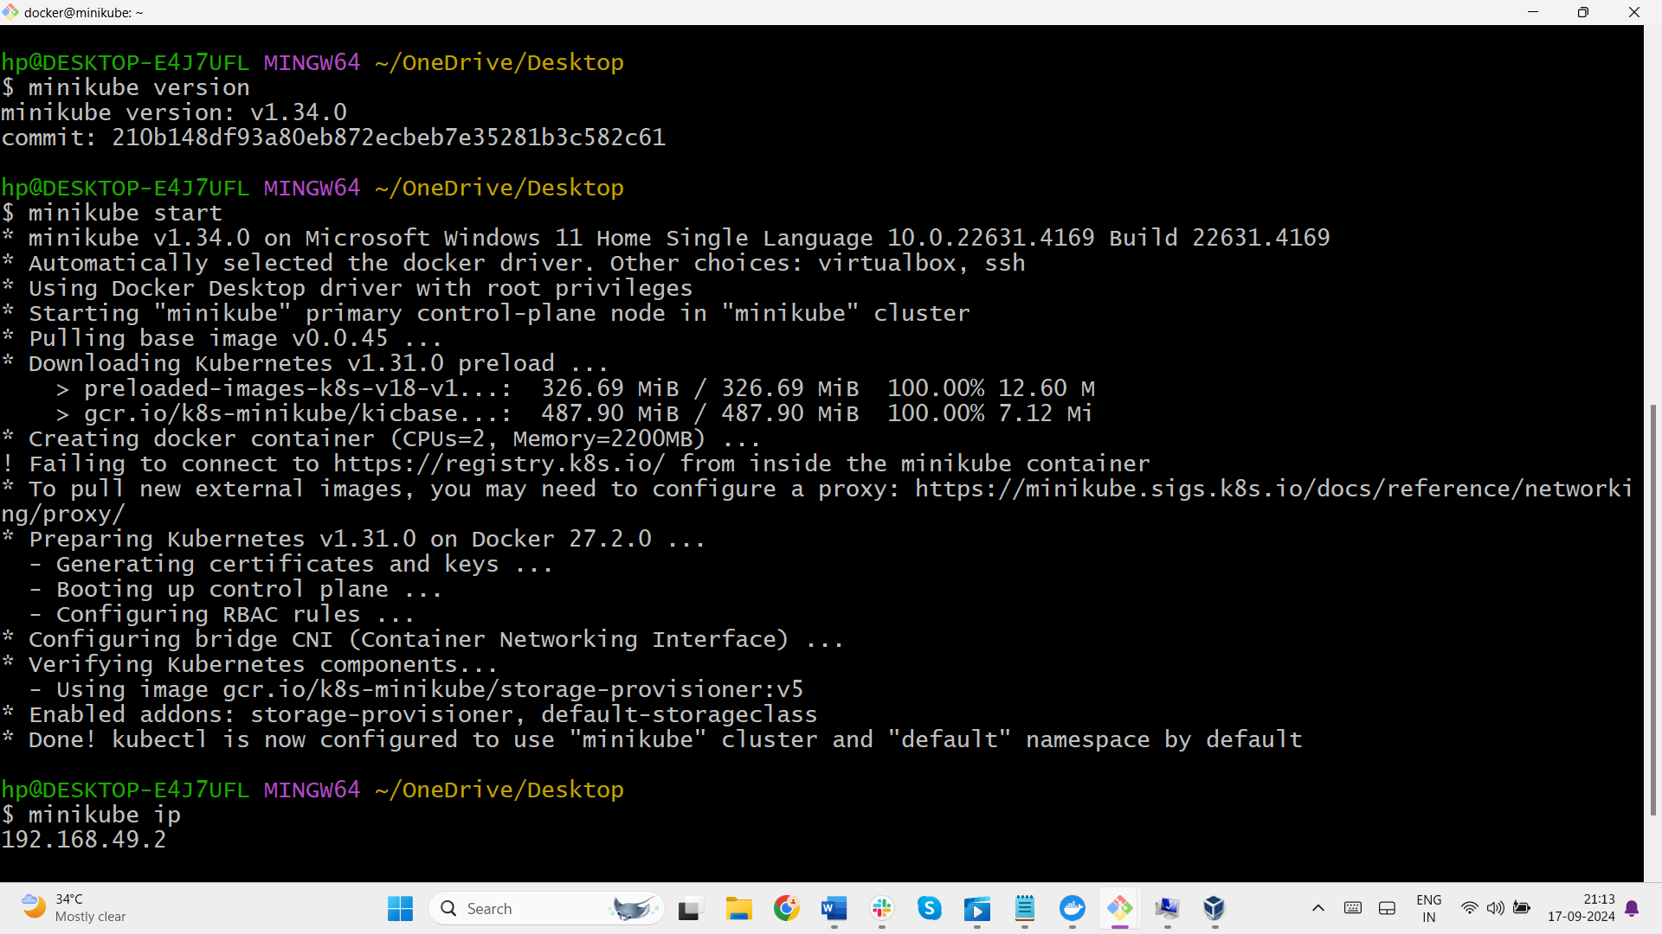

2)Setup k8s master and two worker nodes on aws ec2.

Launch 3 instances named k8master, workernode1, workernode2

Enter the bash script to install docker in 3 instances

#!/bin/bash  
sudo apt update  
sudo apt install [docker.io](http://docker.io/) -y  
sudo systemctl start docker  
sudo systemctl enable docker

After connect to all instances run these commands in all instances

1. apt-get update

2.curl -fsSL https://pkgs.k8s.io/core:/stable:/v1.31/deb/Release.key | sudo gpg --dearmor -o /etc/apt/keyrings/kubernetes-apt-keyring.gpg

3.sudo apt-get install -y apt-transport-https ca-certificates curl gpg

4. echo 'deb [signed-by=/etc/apt/keyrings/kubernetes-apt-keyring.gpg] https://pkgs.k8s.io/core:/stable:/v1.31/deb/ /' | sudo tee /etc/apt/sources.list.d/kubernetes.list

5. sudo apt-get update

6.sudo apt-get install -y kubelet kubeadm kubectl

7.sudo apt-mark hold kubelet kubeadm kubectl

8. sudo systemctl enable --now kubelet

After executing all these instances go to k8master instance

Kube init (execute commands)

Copy these below commands which are shown in k8master instance

# To start using your cluster, you need to run the following as a regular user:

mkdir -p $HOME/.kube

sudo cp -i /etc/kubernetes/admin.conf $HOME/.kube/config

sudo chown $(id -u):$(id -g) $HOME/.kube/config

#next step----

export KUBECONFIG=/etc/kubernetes/admin.conf

kubectl get nodes

curl https://raw.githubusercontent.com/projectcalico/calico/v3.28.1/manifests/calico.yaml -O

ls

kubectl apply -f calico.yaml

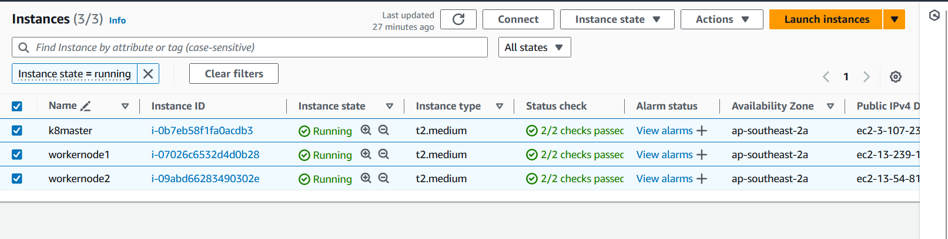

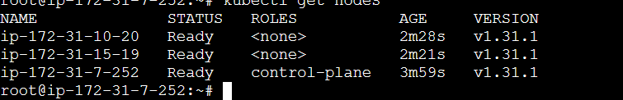

After that goto workernode1 and workernode2 instances run this command

kubeadm join 172.31.7.252:6443 --token ge439k.n80mxumqt9hxmdba \

--discovery-token-ca-cert-hash sha256:993b34ab5e5973caab7d234cf016f494864a28b975f4a1ab15b50c019f0b6f7c

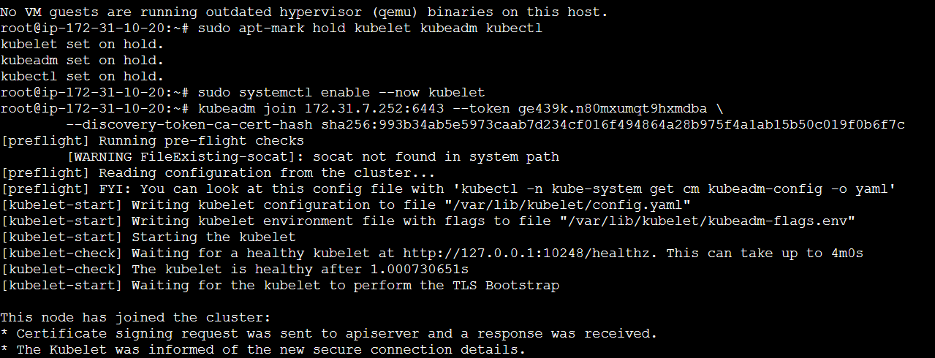

3)Run nginx pod

Execute these below commands in k8master instance

kubectl run nginx –image=nginx

kubectl get pods -o wide

kubectl get pods

